Task A  
 

**Complete an axially symmetrical figure. Solve this.**

ChatGPT

To complete the axially symmetrical figures, you would need to reflect the given shapes across an axis, likely a horizontal or diagonal axis based on the orientation of the parts.

For the first yellow shape:

* The symmetrical completion would involve reflecting the visible portion across its boundary, creating a full triangular or angular figure that mirrors the existing part.

For the second blue shape:

* The blue triangles seem to be a part of a larger shape. Completing it axially would involve reflecting the shapes along the diagonal axis of symmetry, likely forming a geometric figure like a square or parallelogram.

I can create a visualization for this solution if you would like. Would you like me to generate it for you?  
  
 

**Hello, chat! Here is the prompt: Complete an axially symmetrical figure. Objective: what is an axially symmetrical figure and how to distinguish it. Draw the solution.**

ChatGPT

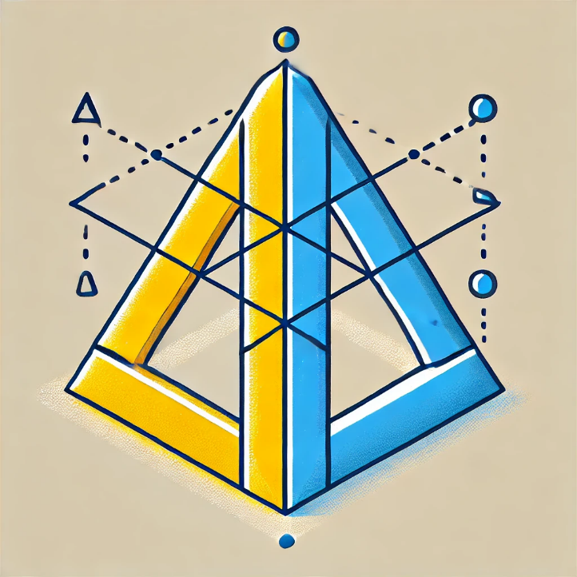

Here is a visual representation of the completed axially symmetrical figures. The yellow and blue shapes are mirrored along their axes, demonstrating symmetry. Let me know if you need any further clarifications!

 

**Complete an axially symmetrical figure. As we know, the symmetry figure is symmetric if we can divide the object into two identical parts, how would you draw this? Draw the first one, then the second figure.**

ChatGPT

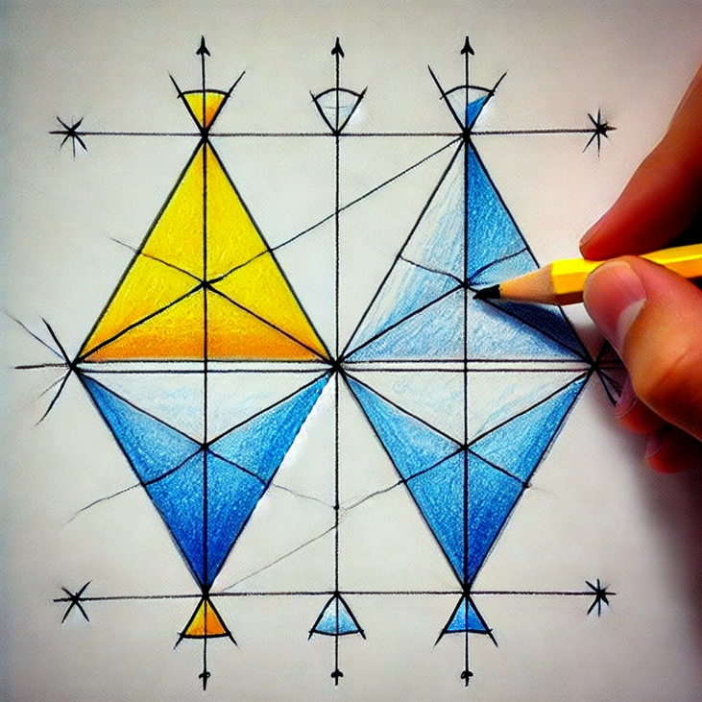

Here is a drawing demonstrating the completion of two axially symmetrical figures. The image shows how to reflect the shapes to create symmetry by dividing them into two identical parts. Let me know if you need further details!

 

**Complete an axially symmetrical figure. To solve this you need to know that the figure must be on the axis, in the direction of the axis. Draw the first figure, then the second figure.**

ChatGPT

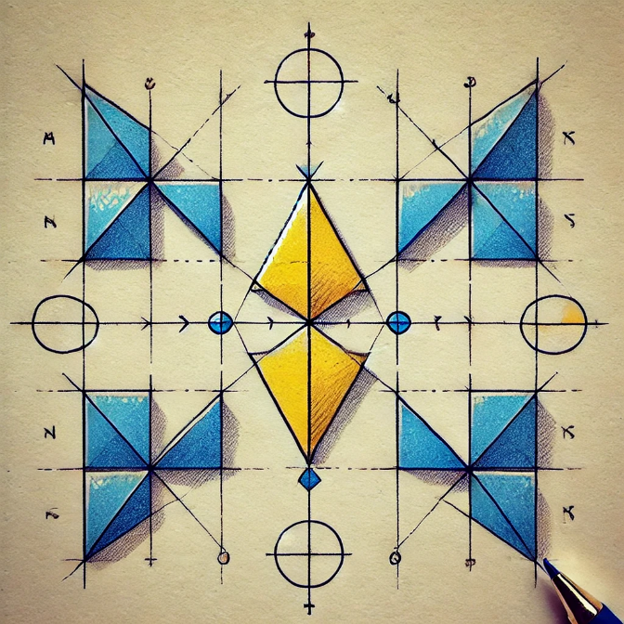

Here is a drawing illustrating how to complete two axially symmetrical figures. The shapes are aligned on the axis and mirrored along the axis to form symmetrical objects. Let me know if you'd like more clarification or further assistance!  
  
 

**Complete an axially symmetrical figure. Please solve this step by step.**

ChatGPT

To complete an axially symmetrical figure, we can follow these step-by-step instructions:

**Step 1: Identify the Axis of Symmetry**

The axis of symmetry is the line that divides the figure into two identical halves. It can be vertical, horizontal, or diagonal. In your figures, the axis of symmetry is likely either vertical or diagonal.

**Step 2: Observe the Given Half of the Figure**

Look carefully at the part of the figure that is already drawn. It may be a part of a triangle, square, or other geometric shape. Pay attention to where the axis of symmetry runs through the figure.

**Step 3: Reflect the Shape Across the Axis**

Now, reflect the given part across the axis of symmetry. Imagine "folding" the figure along the axis so that the two halves match exactly. To do this:

* Draw the missing half by mirroring the positions, angles, and sizes of the given parts.
* Each point in the original half should have an identical point on the other side, the same distance away from the axis.

**Step 4: Connect the Points to Complete the Figure**

Once you have reflected all the points, connect them to form the completed symmetrical figure. Ensure that both sides of the axis are identical.

**Step 5: Verify the Symmetry**

Check that the figure is perfectly symmetrical by comparing the two halves. If the shape looks balanced and identical on both sides, you have successfully completed the axially symmetrical figure.

**Example (Yellow Triangle):**

* **Step 1:** The axis is vertical.
* **Step 2:** You see half of a yellow triangle on one side of the axis.
* **Step 3:** Reflect this triangle across the axis to draw the missing half.
* **Step 4:** Connect the mirrored points to form a complete triangle.
* **Step 5:** Both sides should look identical.

Would you like me to generate an illustration for this step-by-step process?  
  
  
Task B

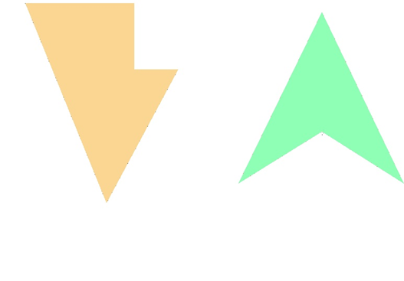

**Complete a) to an axially symmetric figure and b) to a point-symmetric figure. Solve this.**

ChatGPT

To complete these figures based on your description:

**(a) Complete the left figure (orange) as an axially symmetric figure:**

* **Axial Symmetry**: This requires reflecting the shape across an axis (most likely vertical in this case).
* To complete it, reflect the given part of the figure across the vertical axis. The reflected part should mirror the left side of the shape with the exact same angles and sizes on the opposite side.

**(b) Complete the right figure (green) as a point-symmetric figure:**

* **Point Symmetry**: This requires rotating the shape 180 degrees around a central point.
* To complete it, you need to rotate the figure (around its center) and create an identical figure on the opposite side. The result should look like the shape has been flipped upside down at a central point, so both halves are mirror images across a central point.

Would you like me to create a visual representation for these solutions?



**Hello, chat! Here is the prompt: Complete a) to an axially symmetric figure and b) to a point-symmetric figure. Objective: what is an axially symmetric and point-symmetric figures and how to distinguish them. Draw the solution.**

ChatGPT

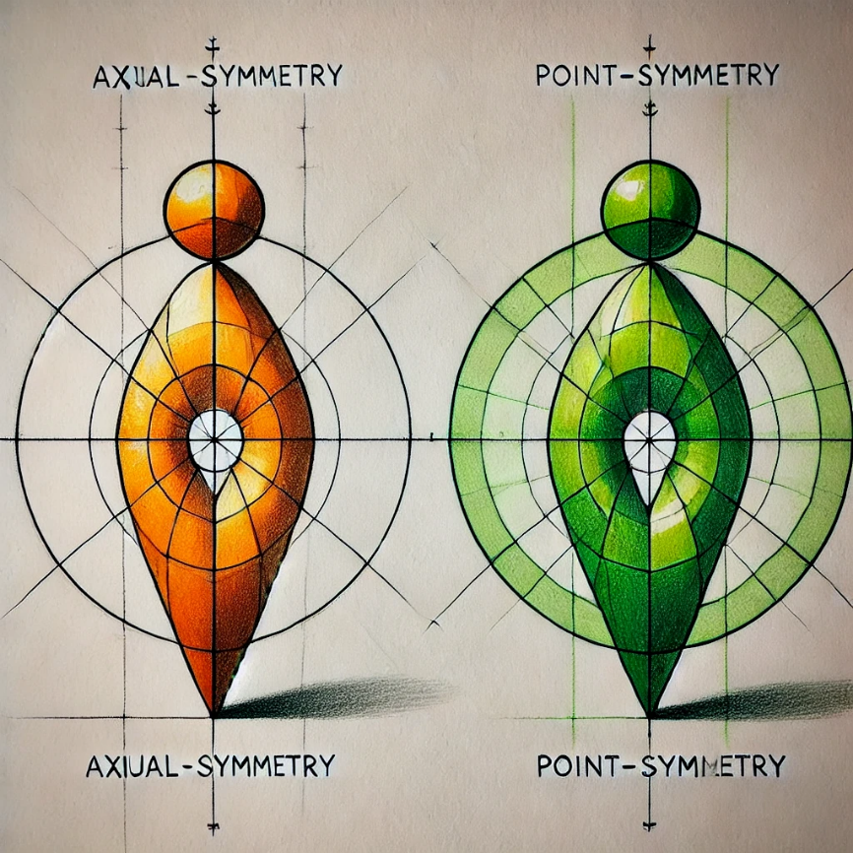

Here is a drawing showing how to complete an axially symmetric figure on the left and a point-symmetric figure on the right. This visual demonstrates the differences between axial and point symmetry, providing clear examples. Let me know if you need any further explanation!



**Complete a) to an axially symmetric figure and b) to a point-symmetric figure. Draw it.**

ChatGPT

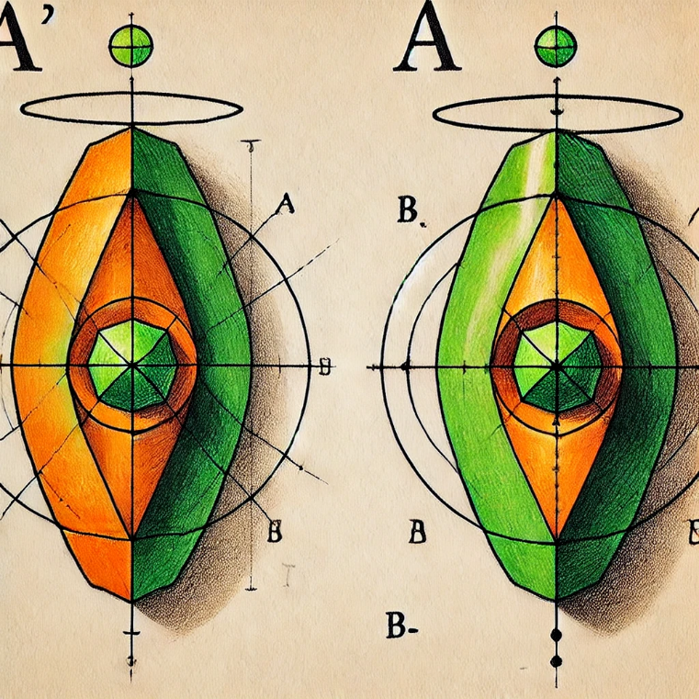

Here is a drawing that completes both figures: (a) is completed as an axially symmetric figure, and (b) is completed as a point-symmetric figure. This illustration highlights the difference between the two types of symmetry. Let me know if you need further explanation!



**Complete a) to an axially symmetric figure and b) to a point-symmetric figure. To solve this you need to know that a point-symmetric figure is made if two equal forms are made by putting a point on an object or shape, but they face different directions. Draw it.**

ChatGPT

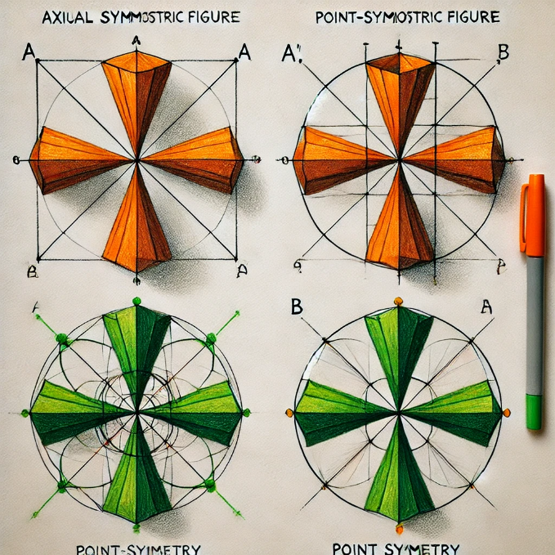

Here is a drawing that completes (a) to an axially symmetric figure and (b) to a point-symmetric figure. It illustrates the process of creating point symmetry by rotating the figure around a central point with the mirrored forms facing different directions. Let me know if you'd like further clarification!



**Complete an axially symmetrical figure. Please solve this step by step.**

ChatGPT

To complete an axially symmetrical figure, follow these step-by-step instructions:

**Step 1: Identify the Axis of Symmetry**

The axis of symmetry is the line that divides the figure into two identical mirror-image parts. In an axially symmetrical figure, any points on one side of the axis will have corresponding points on the opposite side of the axis at the same distance.

**Step 2: Reflect the Given Points**

* Start by observing the points, lines, and shapes on the side of the figure you are given.
* For every key point on the existing shape, reflect it across the axis of symmetry. This can be done by measuring the distance of the point from the axis and plotting a point at the same distance on the other side.

**Step 3: Draw the Missing Parts**

* Once you have plotted the key points on the opposite side of the axis, draw the corresponding lines or curves connecting those points. Ensure that the shapes are consistent with the part that is already given.
* The lines or curves you draw should be identical in length, angle, and curvature to those in the original part of the figure, but on the opposite side.

**Step 4: Verify the Symmetry**

* After completing the figure, check that both halves of the shape are identical. You can imagine "folding" the figure along the axis of symmetry, and the two halves should overlap perfectly.

**Example:**

Imagine you are given half of a triangle with a vertical line as the axis of symmetry:

1. **Step 1**: The vertical axis is your line of symmetry.
2. **Step 2**: Identify the three corners (vertices) of the triangle on the left side of the axis.
3. **Step 3**: Reflect those points onto the right side by measuring the distance from the axis.
4. **Step 4**: Connect the points on the right side to complete the triangle, ensuring both sides are identical.

Would you like me to create a visual guide for this step-by-step solution?